EXERCISE 3 - #pragma omp master
Files : exercise03.c
Compile / run
gcc -fopenmp exercise03.c -o exercise03
OMP_NUM_THREADS=4 ./exercise03

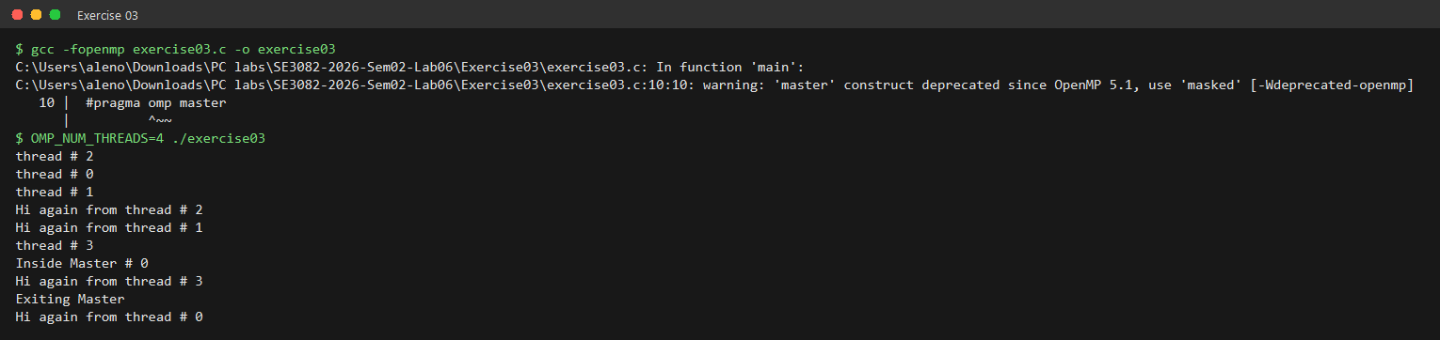
How omp master works in this program
------------------------------------
* The master block is executed ONLY by the master thread (thread 0), so
"Inside Master # 0" is always printed by thread 0 and only once.
* Unlike single, master has NO implicit barrier - the other threads do
not wait. In the output thread 3 prints "Hi again" before the master
block has even started, and the master lines are interleaved with the
other threads' output.
* gcc warns that master is deprecated since OpenMP 5.1 in favour of
#pragma omp masked, which behaves the same way.

